GREEK COMPANIES PROFILE

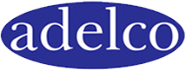
1. ADELCO S.A.

Adelco, over the ages, continues to care for people’s health, well-being and quality of life by offering high quality products at competitive prices. Fulfilling their mission above their aim is: To gain leadership in the production and promotion of pharmaceutical and consumer products. To apply stringent quality standards, both in the production process and offered services, maintaining consistency and scientific responsibility. To adapt to the international environment in order to expand sales, enter new markets and improve their services according to the requirements of each country. To meet the needs of the patient and client, taking care of people and improving their quality of life. Employing as assets to our company the finest scientists with devotion to the strategy and vision of the company.
Adelco has a dynamic presence in Greece since 1934. Today Adelco operates in two main areas: pharmaceuticals and consumer products.
In the field of Pharmaceuticals, Adelco circulates more than 60 formulations (Filicine, Minitran, Stedon, Normolose-H, Paroticin) for the treatment of diseases such as megaloblastic anemia, mental disorders, anxiety, insomnia, depression, hypertension, otitis media. In the field of consumer products Adelco offers the range OM - OR, the first shampoo manufactured and marketed in Greece, as well as the new range of cosmetic products Adelco Kids, Adelco Intense SPA, OM-OR Naturals, Adelco Velvet hand & body, and Adelco Men's Concept. The area of consumer products has been enriched with natural health products and dietary supplements, New Roots and a natural general purpose detergent Green&Clean.
One of the key factors of the company's success is due to the exceptional personnel staffing the sales departments, marketing, export, production, R&D, quality control and quality assurance. The company occupies a modern vertical production unit of 10000 sq.m., with 65 skilled persons, and a well-organized group of representatives throughout Greece and internationally.

Representative:
MICHAEL PATERAKIS, BUSINESS DEVELOPMENT MANAGER

m.paterakis@adelco.gr, http://www.adelco.gr/

2. BRIGHT SPECIAL LIGHTING S.A.

One the most modern and dynamic companies in Europe is the Greek company BRIGHT SPECIAL LIGHTING S.A. which was founded in 1989. The company's success lies in the most excellent knowledge of lighting technology.
BRIGHT continues to reinforce its leadership in the field of lighting. The products and lighting systems are characterized by innovative design and feature the latest technology. While the specialized personnel conducts lighting studies with environmental care. BRIGHT distinguishes for its consistency, flexibility, quality and for its economical prices customized to every client’s need. The company owns trucks and a large network of partners (shipping and cargo companies) to speed deliveries made in the country and abroad. Furthermore, BRIGHT has developed the Department of special constructions (Tailor-made Lighting) for lighting fixtures depending on the requirements of each project.
Its success in the field of lighting for 50 years and its impressive portfolio of lighting projects make BRIGHT, your ideal partner and consultant in the area of ​​artificial lighting.
Lighting products categories:
Spotlights, Lighting Track Systems, Downlight Recessed Spots, Downlight Metal Halide, Downlight Energy Saving, Diffusive Lighting, Mounted On Ceiling, Factory Lighting, Outdoor Lighting, Interior Lighting

Representative:
VASILIOU NIKOLAOS, VICE PRESIDENT & OWNER
nvasiliou@bright.gr, https://www.bright.gr/

3. INTRACOM TELECOM doo BELGRADE
Intracom Telecom is a global telecommunication systems & solutions vendor operating for over 40 years in the market. The company was derived from Intracom, a company that began operating in 1977 with 10 employees in Athens, Greece, manufacturing and assembling telecommunication equipment to address domestic needs. In 2005, Intracom was transformed into a holding company and the telecommunications business unit became a company under the name Intracom Telecom.
During its four decades of history, the company has successfully participated in major ICT projects worldwide and has received awards and distinctions for its technologies and work environment. Today, Intracom Telecom employs over 1,700 highly-skilled professionals and operates own R&D and production facilities. Its subsidiaries span across Europe, Russia & the CIS, the Middle East & Africa, Asia and North America.
Intracom Telecom has extensive know-how and a proven track record in the telecommunications market, serving more than 100 renowned customers in over 70 countries. The company develops and provides products, solutions and professional services primarily for fixed and mobile telecom operators, public authorities and large public and private enterprises.
The company's core business offerings include:
- Wireless Access & Transmission
- Telco Software Solutions
- ICT Services & Smart City Solutions
- Energy Solutions

Representatives:
PARTSALIS EFTHYMIOS, CEO,
epartsalis@intracom.rs, http://www.intracom-telecom.com
VUJETIC MILAN, TECHNICAL DIRECTOR,
mvujetic@intracom.rs, http://www.intracom-telecom.com

- YIOTIS S.A.
YIOTIS S.A. is one of the oldest yet most innovative food companies in Greece. It was established in 1930, by Ioannis and Maria Yiotis who started their business with the vision to provide children with rich in nutritive elements food, originating from top quality and locally cultivated raw materials such as corn and rice.
During its 87 years course, YIOTIS S.A is one of the leading companies in the food and beverage industry and is committed in setting new trends and opening new paths for Greek dietary habits. From this point of view, Company’s history is a series of significant milestones and successful moments. It was the first to introduce baby food cereals, self-raising flour, instant dessert kits, low glycemic index products and many other innovative products for home cooking and baking, which meet even the most demanding needs of its customers.

The vision of YIOTIS S.A. is to create innovative products of high nutritional value and assured quality, which will satisfy the nutritional needs and indulgence of the entire family in the modern age.
Yiotis S.A. strives to continuously expand its portfolio of products with new offerings of high nutritional value, in order to fulfill the daily needs of contemporary consumers and have natural, effective and wholesome benefits for their overall quality of life.
The emanation of this philosophy is the launch and incorporation of 3 new product categories in the YIOTIS range of products in 2009: A low glycemic index range with the brand name SWEET&BALANCE, an organic product line with the brand name ORGANIC and a healthy food product line with the brand name FΥTRO.

Research & Development and Quality Assurance are one of the Company's most dynamic departments and one of the most advanced in the Greek food industry.

Yiotis S.A. has won several distinctions over the years such us: 2016 Self Service Excellence Awards, 2016 Superbrands, 2013 Made in Greece ‘Innovative Product’ Awards –for Sweet & Balance range, 2005 Superbrands Award, 2000 Brand Product Prize by ACCIIn 2000, 1998 1st Award Mad Advertising TV Spot, 1997 Oppack Awards, 1997 Bronze Lion for Yiotis Mad Advertising TV Spot, 1994 1st International Prize Sial D’or Paris for Yiotis Instant Desert Kits

Products: Baby Cereals, Infant Milk, Confectionary, Baking and Cooking Products, Instant Desserts, Dessert Kits, Cake Mixes, Chocolate Drinks, Chocolates, Sweet & Balance Low Glycemic Index Desserts (suitable for diabetics), Healthy nutrition complete product range (Fytro and Bio- Organic range).
Brands: JOTIS, SANILAC, HEMO, CAOTONIC, SWEET&BALANCE, FYTRO, BIO-ORGANIC

Representative:
MOSCHOVELIS SOCRATES, AREA SALES MANAGER
smoschovelis@jotis.gr, http://www.jotis.gr

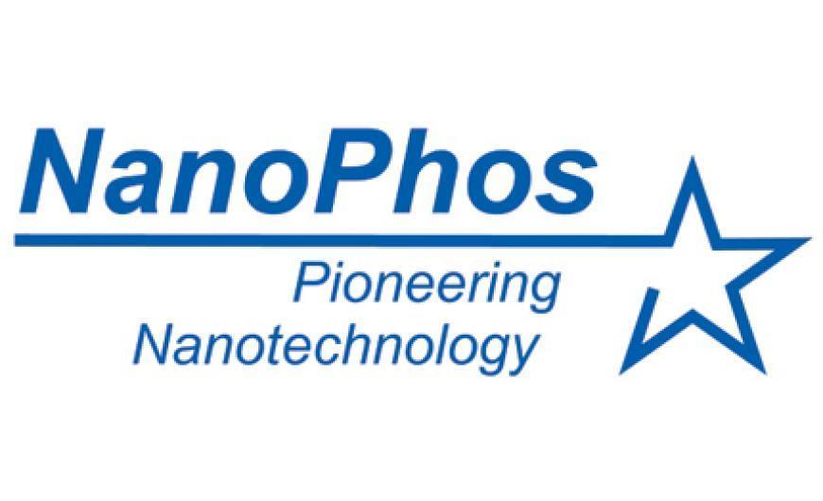
- NANOPHOS S.A.

Since its establishment in 2005 in Lavrio, Greece, NanoPhos has been researching, developing, producing and trading “smart” materials to solve everyday problems with the power of nanotechnology.
By harnessing nanotechnology, the company seeks to create a more comfortable, safe and trouble-free living environment.
At NanoPhos, they craft materials that effectively solve common problems. They develop multiple nanotechnology driven formulations to add functionality and boost energy efficiency in buildings and construction projects.
They transfer innovations out of their lab and into the hands of consumers. By taking advantage of the nanoparticles benefits for the end user, NanoPhos provides solutions for common "irksome" problems such as moisture, mould and thermal insulation.
Their vision is clear: "Tune the nanoworld to serve the macroworld" – in simple terms make nanoparticles serve the needs of people.
A broad range of patented, high-quality and environmentally friendly coating products add functionality and unique properties in construction projects, industrial units, marine structures or vessels.
Numerous international awards underline the company’s efficiency, ecological awareness (i.e. 2010 World Expo, the 100% Detail exhibition, the GAIA awards), or innovative character (the President of Microsoft- Bill Gates - distinction in 2008).
NanoPhos has also been selected as a National Champion for the 2016/2017 European Business Awards Innovation. NanoPhos received “Technical Achievement Award” during the 2017 Lloyd’s List Greek Shipping Awards - 2017.
NanoPhos S.A. products are exported to over 25 countries worldwide.

Representative:
MAGNISSALIS ANASTASIOS, COMMERCIAL DIRECTOR
amagnissalis@nanophos.com, http://www.nanophos.com

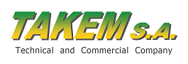
- TAKEM S.A.

TAKEM SA has been working with American company Catalytic Generators for more than 25 years offering an innovative and SAFE method for Fruit ripening (especially bananas). Ethylene production through a Catalytic Generator ensures that fruit is ripened uniformly, conveniently and in a safe way. With our system there is no need to store large quantities of compressed ethylene at a fresh produce warehouse or ripening center. Our on-site process of producing ethylene as it is needed. We are working directly with fruit importers and wholesalers that own ripening rooms and also with technical refrigeration companies that build such rooms. We own the majority of the Greek market and wish to expand our business in the area. We also offer service and excellent know-how in the ripening business.
We are looking for wholesalers/importers of fresh fruit (especially bananas) that have their own ripening rooms and wish to try our safe and hassle-free ripening method with catalytic generators. Also we are looking to work with technical refrigeration companies that build ripening rooms and are looking for the best tried and tested ripening method to offer to their customers.

Representative:
ELEFTHERIOU ANGELIKI, MARKETING MANAGER
angeliki@takem.gr, http://www.catalyticgenerators.gr/

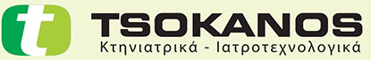
- TSOKANOS S.A.

TSOKANOS SA Veterinary Logistics, Warehouse & Distribution Services is a100% family owned Greek company established in 1980 and has its headquarters in Thessaloniki. Today, TSOKANOS is the leading veterinary wholesaler in Greece with a total of 3.500m² of warehouse capacity and over 10.000 clients. There are a phenomenal 4.500 catalogue products available, ranging from veterinary pharmaceuticals, vaccines, instruments, consumables, equipment for small and large animals to unique pet accessories and nutritional supplements.
Our company deals in a huge variety of products (over 4.500 codes) that cover all needs of the professional veterinarian, of the breeder, of the public sector and of the animal lover.
Products
- Electronic and visual marking products
- Dietary products
- Disposables
- Veterinary medicine
- Clinic and lab equipment
- Veterinary instruments
- Public health products
- Zootechnical products
- Pet products
Fast and reliable deliveries are pivotal in today’s business. TSOKANOS SA has invested in the latest technology in picking and packingcustomers’ orders to ensure that deliveries reach its customers quickly, correctly and conveniently and meet the different requirements of the various local partners. Moreover, implementation of cutting edge ERP, WMS and CRM systems gives the company a unique competitive advantage.
The strategic emphasis on investing more in the organisation’s own products and using them to expand the range played a significant role in the company's rapid growth. Alongside this, the constant expansion of sales markets through the establishment of region-specific partners also had an extremely positive effect. Our team includes veterinary doctors and product managers, who manage product development, technical sales back-up and training programmes.
Representative:
TSOKANOS NIKOLAOS, MANAGING DIRECTOR
tsokanos@gmail.com, http://www.tsokanos.gr/
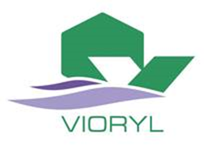
8. VIORYL S.A.

VIORYL S.A. was originally created in 1948 as a research laboratory for natural products and soon expanded its activities in the production of fragrances and flavors, with aim to supply the national Greek market with adequate compounds.
Thereafter, early in the 60s we expanded in fine chemicals synthesis and late in the 80s moved towards agro active products (pheromones, growth regulators, special fertilizers, ecological insect traps etc).

VIORYL’s production line includes mainly the following products:
* Fragrances for soaps, detergents, colognes, cosmetics, air fresheners, household applications, candles, fine perfumes and many others.
* Natural & Natural identical flavors for bakery, soft drinks, beverages, fruit juices, dairy products, ice creams, confectionery, jams, chewing gums, toothpaste etc.
* Important range of aromatic fine chemicals, used by the flavor producers

VIORYL’ s extensive progress in new products is the direct result of its continuing participation in the most advanced European and International scientific programs, which include the development of new technologies This VIORYL’ s intense & innovative research is supported by an experienced team of Analytical Department, equipped with the latest technology equipment and the Company reinvestment 15% of its yearly turnover for research and development in new products and new production processes.
Since 1999 has been certified by TUV with ISO-9001 & FSSC 22000 Certifications.

Representative:
ANTONIOS KAZAKOS, AREA EXPORTS MANAGER
akazakos@vioryl.gr, http://www.vioryl.gr

